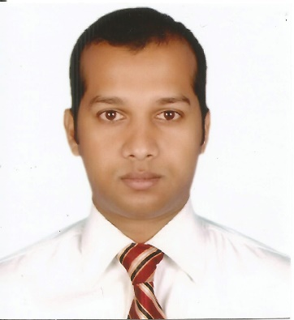

**Resume of Md.Shakhawatul Islam**

Address: Ali mohammad khan road, Adorshabag, Post: Para-Dogair-1362, Demra, Dhaka .

Mobile No:+8801674566625

E-mail: sujan.ken@gmail.com

# Objective

I am enthusiastic to secure a position in a well-established organization having opportunity to develop long-term career where I can actively contribution for achieving organizational goals and objective through my sincerity, hardworking and dedications.

# General Abilities

Can manage independently or as a team leader any local, multi-national, or cross-cultural organization’s Trade, Distribution or Research & Development plan in a competitive environment. I can work under pressure to meet deadlines bearing in mind of positive thinking after considering the protective proactive and practical approach.

# Career Summary

**Present job**  **Executive – Marketing**

Hasan Trading Company

1st June 2014 to till continuing

**Immediate past job** **Executive – Vat & Tax**

Modern Herbal Group, Factory

1st January 2012 to 31st May 2014

# Core Strengths & Skills

* Optimistic.
* Proactive.
* Leadership capability.
* Problem solving skill.
* Analytical skill.
* Ready to learn.
* Ability to cope with every situation.
* Event Management

# Workshop and Seminar Participation

* **Workshop on “Bajaj Genuine Parts identification”**

Date: 5th to 12th June, 2016

Place: Bajaj Auto, India

* **Workshop on “Unique Selling Proposition”**

Date: 13th to 15th June, 2016

Place: Varroc Group, India

* **Workshop on “Consumer Behavior”**

Date:16th to 17th June, 2016

Place: Greaves Cotton, India

* **Mechanic Training on “Importance of Using Genuine Parts”**

Date: 10th to 14th August, 2016

Place: Jessore.

**Customer Relationship Management**

* + Principal responsibility is to establish flawless customer service.
  + Follow-up customer’s queries and update those accordingly, coordinate with other department related with customers issues.
  + Identify and assess for new business development and build an active relationship with customers.
  + Excellent communication skill with strong sense of responsibilities
  + Provide accurate, valid and complete information by using the right tools and liaison with cross function team.
  + Handle complaints, provide appropriate solutions and alternatives within the time limits and follow up to ensure resolution.
  + Handling escalated calls, complaints, questions, and queries as necessary.
  + To increase the profitability and productivity of the company.
  + To monitor and ensure processes and control systems for existing customers.
  + To achieve daily quantitative targets and the service levels.
  + Deliver prompt and professional solutions for customer inquiries via phone, email etc.
  + Build relationship with other agents to secure business.
  + During the capacity constrained situation, negotiate lead time with customer.

# Extra Curriculum Activities

**Computer Literacy**

Have practical Knowledge on -

* + - Windows XP, Windows 7
    - Microsoft Office [MS Word, MS Excels, MS Power point]
    - Advance Excels
    - Computer Hardware
    - Primary troubleshoot on Windows [installation]

# Language skill

* English & Bengali-Good at listening, reading, writing & speaking
* Hindi -Good at listening & speaking.

# Personal Details

# Father’s Name : Md. Sirajul Islam

# Mother’s Name : Salma Akter.

# Date of Birth : 17 September, 1984

# Nationality : Bangladeshi.

# National ID : 8698919027

# Academic Qualification

**University Asian University Of Bangladesh**

Certification Bachelor of Business Administration

Dates attended 2004-2008

Qualifications gained 2.830 out of 4

**Collage Dhaka College**

Certification Higher Secondary Certificate - H.S.C

Dates attended 2002

Qualifications gained 2nd Division

**School Shamsul Haque khan High School,Dhaka**

Certification School Secondary Certificate - S.S.C

Dates attended 2000

Qualifications gained 1st Division

# References

|  |  |  |  |
| --- | --- | --- | --- |
|  | **Mahabubul Haque Sojib** |  |  |
|  | ASP |  |  |
|  | SPBN |  |  |
|  | Mohammadpur, Dhaka. |  |  |
|  | Contact No : 01718-147124 |  |  |
|  |  |  |  |



Shakhawatul Islam